# Lab 1 and 2 Screenshots

## Lab1 – Linux installed and working successfully(ls)

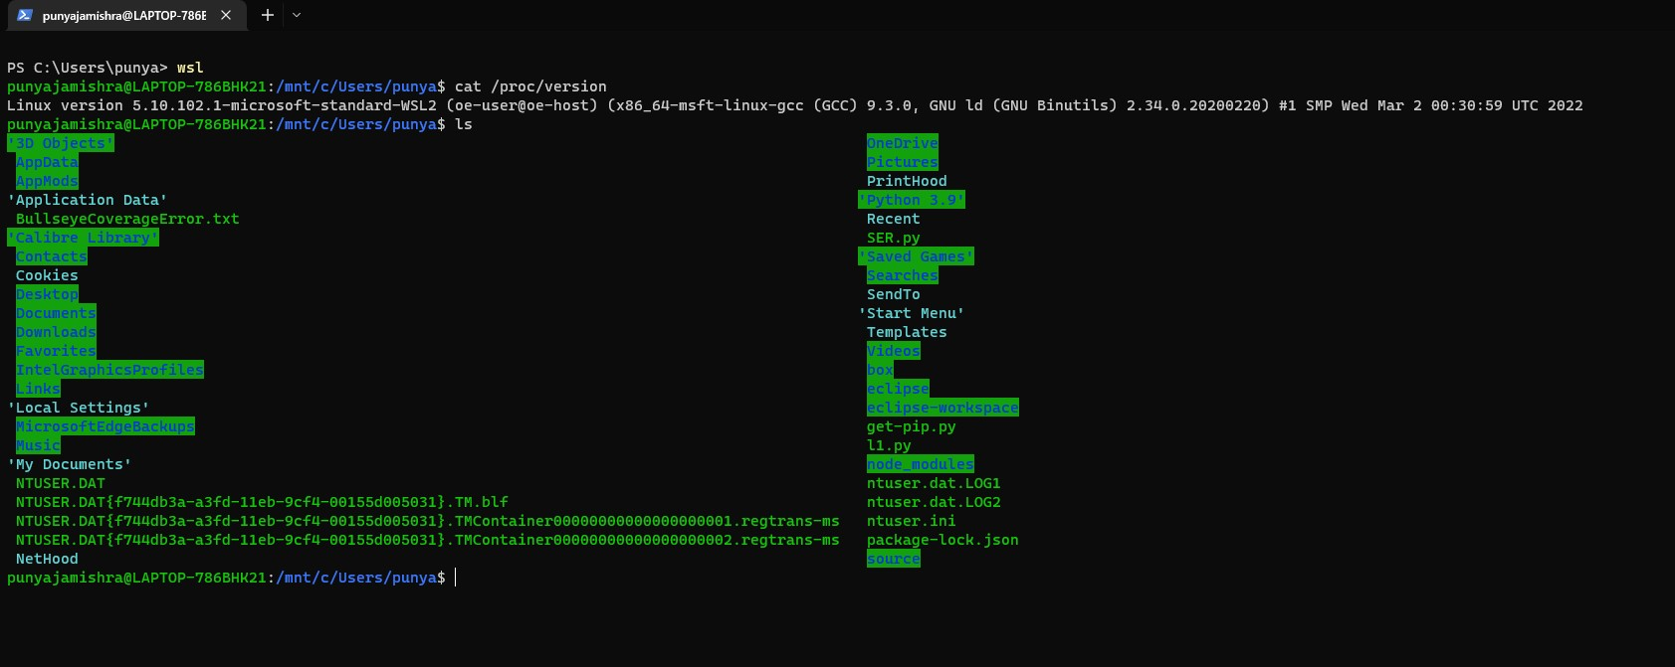

## Lab 2 code

Copied and pasted the code below:

#include<iostream>

#include<vector>

#include<string>

#include<math.h>

using namespace std;

float calculateDiagonal(float passedArray[10][10]){

    float sumOfDiagonal = 0;

    for( int row = 0; row < 10; row = row + 1 ){

        for(int column = 0; column < 10; column = column + 1 ){

            if(row == column){

                sumOfDiagonal = sumOfDiagonal + passedArray[row][column];

            }

        }

    }

    return sumOfDiagonal;

}

void referenceFunction(float (*array2D)[10]){

    cout<< "Now Passing array as a reference" << endl;

    float sum = 0, sumOfDiagonal = 0;

       for( int row = 0; row < 10; row = row + 1 ){

        for(int column = 0; column < 10; column = column + 1 ){

            array2D[row][column] = pow(array2D[row][column],2);

        }

    }

       for( int row = 0; row < 10; row = row + 1 ){

        for(int column = 0; column < 10; column = column + 1 ){

            sum = sum + array2D[row][column];

            if(row == column){

                sumOfDiagonal = sumOfDiagonal + array2D[row][column];

            }

        }

    }

    cout << "Sum of all vlaues in the 2-D array is: " << sum << endl;

    cout << "Sum of diagonal in the 2-D array is: " << sum << endl;

}

int main(){

    //defining array

    float array2D [10][10] =  {

        {0.0, 0.1, 0.2, 0.3, 0.4, 0.5, 0.6, 0.7, 0.8, 0.9},

        { 1.0, 1.1, 1.2, 1.3, 1.4, 1.5, 1.6, 1.7, 1.8, 1.9 },

        { 2.0, 2.1, 2.2, 2.3, 2.4, 2.5, 2.6, 2.7, 2.8, 2.9 },

        { 3.0, 3.1, 3.2, 3.3, 3.4, 3.5, 3.6, 3.7, 3.8, 3.9 },

        { 4.0, 4.1, 4.2, 4.3, 4.4, 4.5, 4.6, 4.7, 4.8, 4.9 },

        { 5.0, 5.1, 5.2, 5.3, 5.4, 5.5, 5.6, 5.7, 5.8, 5.9 },

        { 6.0, 6.1, 6.2, 6.3, 6.4, 6.5, 6.6, 6.7, 6.8, 6.9 },

        { 7.0, 7.1, 7.2, 7.3, 7.4, 7.5, 7.6, 7.7, 7.8, 7.9 },

        { 8.0, 8.1, 8.2, 8.3, 8.4, 8.5, 8.6, 8.7, 8.8, 8.9 },

        { 9.0, 9.1, 9.2, 9.3, 9.4, 9.5, 9.6, 9.7, 9.8, 9.9 }

        };

    //variale to store sum of all values in 2D array

    float sum = 0;

    //traversing through 2D array using nested loops

    for( int row = 0; row < 10; row = row + 1 ){

        for(int column = 0; column < 10; column = column + 1 ){

            sum = sum + array2D[row][column];

        }

    }

    //printing the sum

    cout << "Sum of all vlaues in the 2-D array is: " << sum << endl;

    //printing sum of diagonal

    float sumOfDiagonal = calculateDiagonal(array2D);

    cout << "Sum of diagonal in the 2-D array is: " << sum << endl;

    referenceFunction(array2D);

}

### Output

## Lab2 – helloworld.cpp

## Lab2 – Factorial.cpp

